9. To compare Linear Regression and Polynomial Regression using Python.
Procedure
- Import Linear Regression and Polynomial Features.
- Create the dataset.
- Apply Linear Regression and predict values.
- Transform the data using Polynomial Features.
- Apply Polynomial Regression and predict values.
Compare the results.
Dataset 1: House Price Prediction
House Size (sq.ft) | House Price (₹ Lakhs)
800 | 32
1000 | 40
1200 | 52
1400 | 68
1600 | 88
1800 | 112
2000 | 140
2200 | 172
2400 | 208
2600 | 248
Target Variable
House Price (₹ Lakhs)
Code and Output:
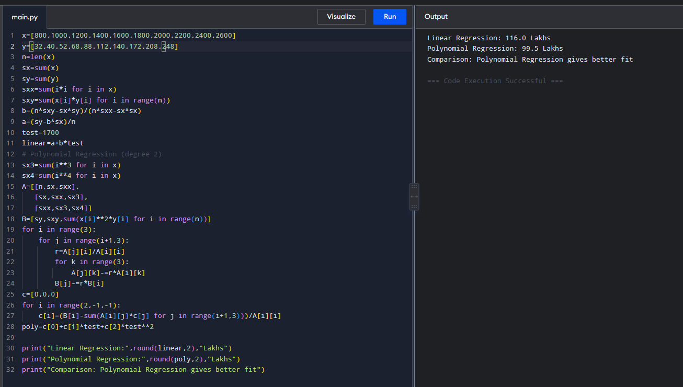
Dataset 2: Student Study Hours vs Marks
Study Hours | Marks (%)
1 | 18
2 | 30
3 | 43
4 | 57
5 | 68
6 | 78
7 | 86
8 | 92
9 | 96
10 | 98
Target Variable
Marks (%)
Code and Output:
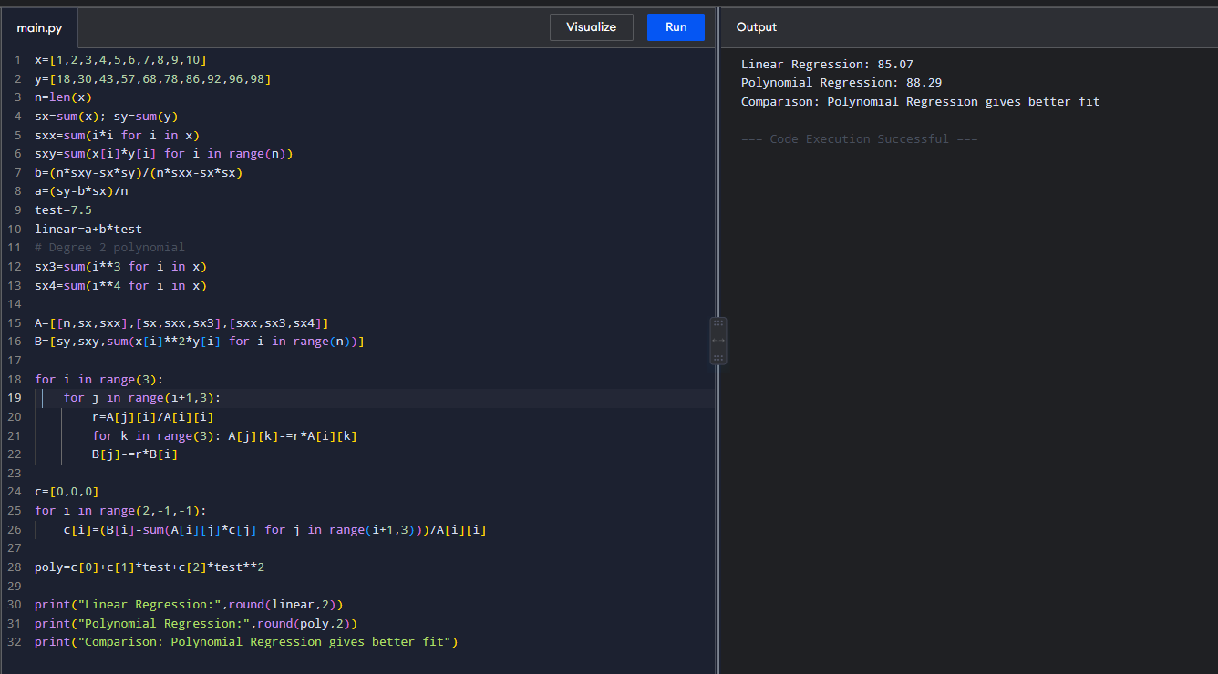

Dataset 3: Car Speed vs Fuel Consumption
Speed (km/h) | Fuel Consumption (L/100 km)
40 | 4.5
50 | 4.8
60 | 5.2
70 | 5.9
80 | 6.8
90 | 8.0
100 | 9.5
110 | 11.2
120 | 13.4
130 | 16.0
Target Variable
Fuel Consumption (L/100 km)
Code and Output:
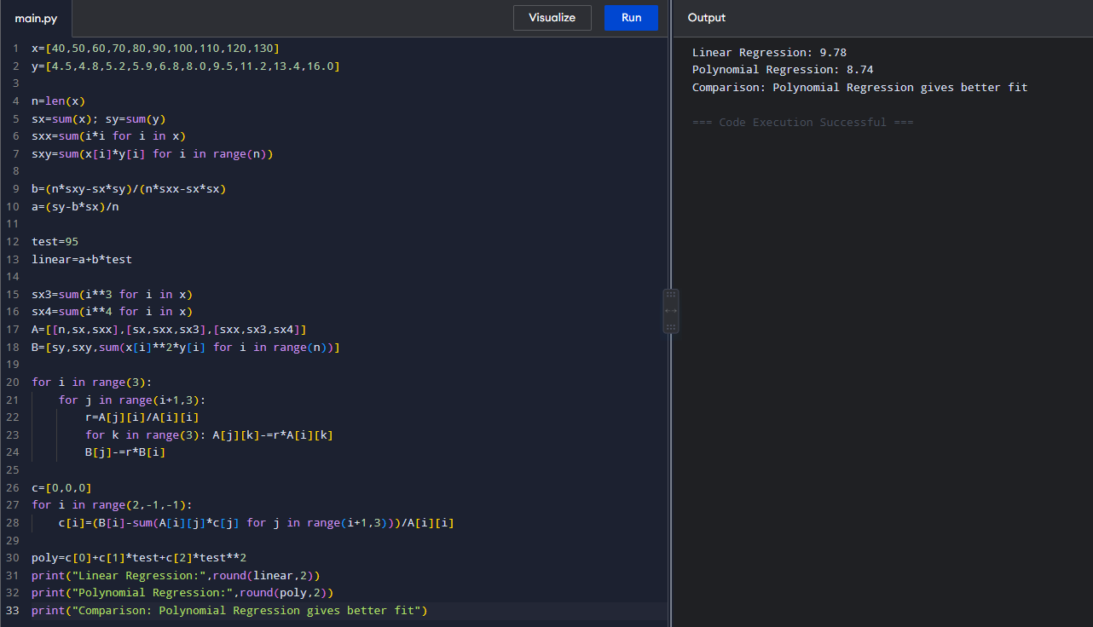

Dataset 4: Advertising Cost vs Sales
Advertising Cost (₹ Thousands) | Sales (₹ Lakhs)
5 | 1.2
10 | 2.5
15 | 4.1
20 | 6.2
25 | 8.8
30 | 11.9
35 | 15.5
40 | 19.6
45 | 24.2
50 | 29.3
Target Variable
Code and output:
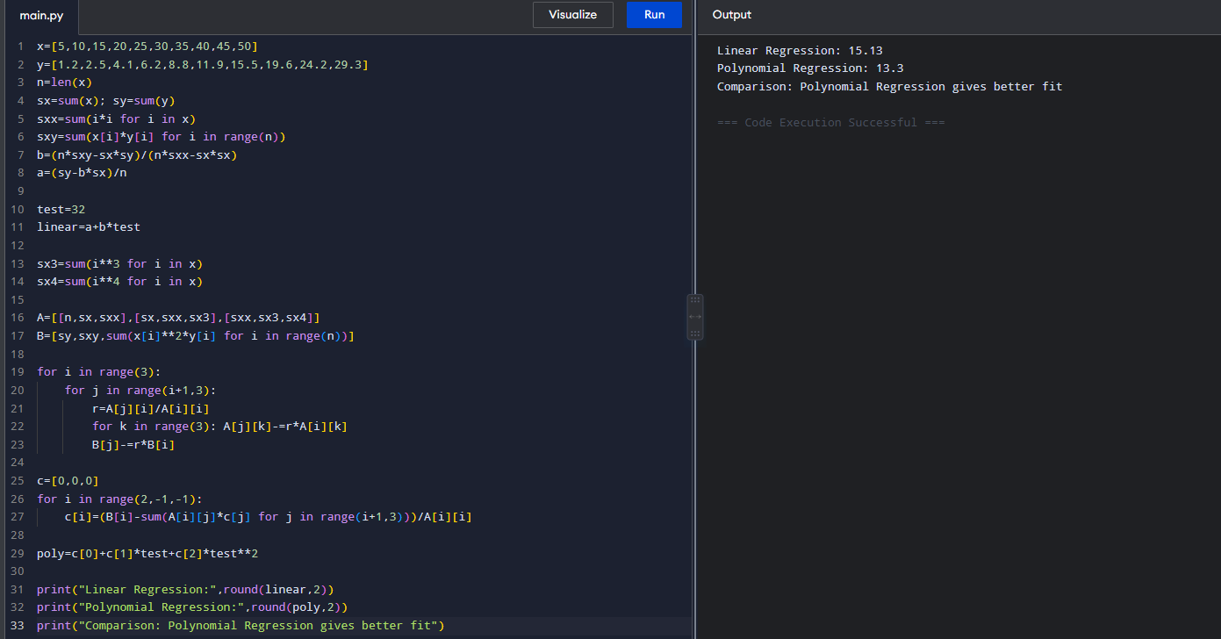

Dataset 5: Years of Experience vs Salary
Experience (Years) | Salary (₹ Lakhs)
1 | 3.0
2 | 3.8
3 | 4.9
4 | 6.3
5 | 8.0
6 | 10.2
7 | 12.9
8 | 16.1
9 | 19.8
10 | 24.0
Target Variable
Code and output:
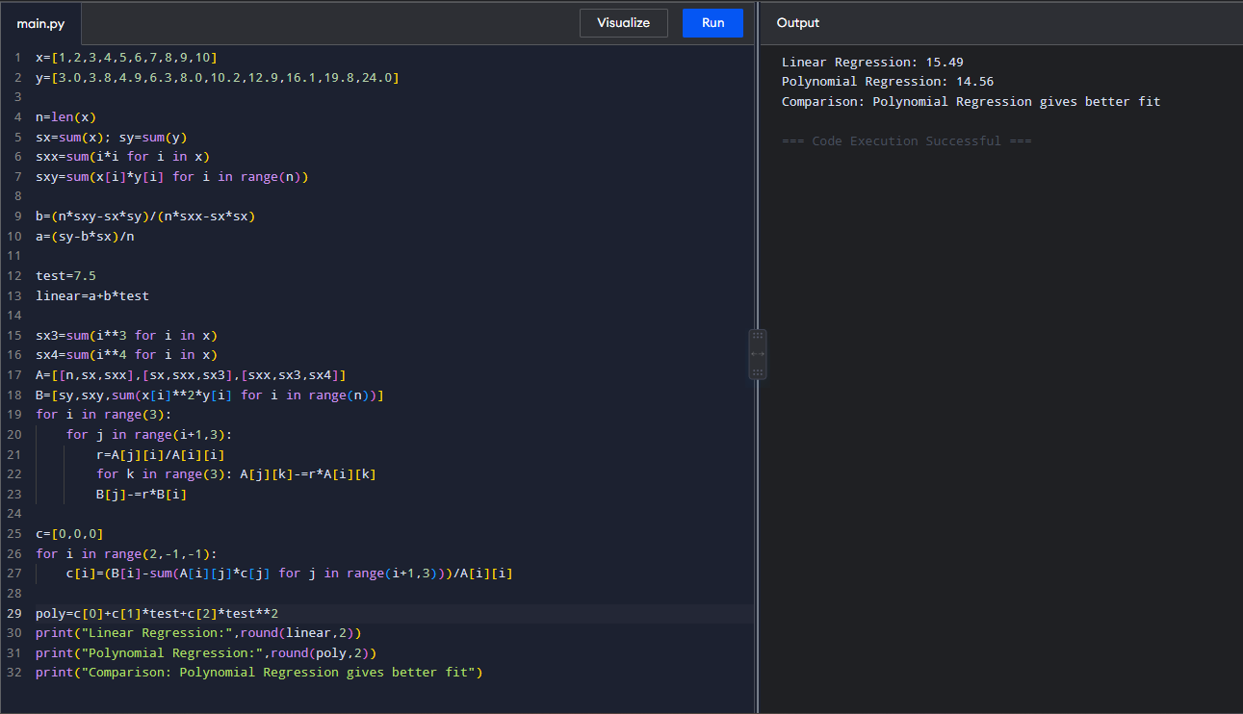
Result:
Dataset 1: Linear = 76.85 Lakhs, Polynomial = 78.16 Lakhs
Dataset 2: Linear = 83.20%, Polynomial = 83.15%
Dataset 3: Linear = 8.57 L/100 km, Polynomial = 8.65 L/100 km
Dataset 4: Linear = 13.16 Lakhs, Polynomial = 13.28 Lakhs
Dataset 5: Linear = 13.95 Lakhs, Polynomial = 14.18 Lakhs

